

In our digital world, securing your network is crucial. Which type of firewall is right for you? Here’s a quick guide:  
  
🚀 Key Firewall Types 🚀  
- Packet Filtering: Basic, filters data packets based on rules.  
- Circuit-Level Gateway: Verifies TCP handshakes for secure connections.  
- Application-Level Gateway: Filters traffic at the application layer.  
- Stateful Inspection: Monitors active connections for enhanced security.  
- Next-Generation Firewall (NGFW): Integrates malware filtering, deep packet inspection, and intrusion prevention.  
  
🛡️ Other Important Firewalls 🛡️  
- Cloud-Based (FWaaS): Scalable security for cloud environments.  
- Proxy: Filters traffic at the application level.  
- Unified Threat Management (UTM): Combines multiple security features.  
- Stateful Multilayer Inspection (SMLI): Advanced protection across multiple layers.  
- Virtual: Secures virtual environments.  
- Container: Protects containerized applications.  
- Host-Based: Security for individual devices.  
  
🔥 Latest Trends for 2024  
- AI-Driven Firewalls: Real-time threat detection using machine learning.  
- Zero Trust Network Access (ZTNA): “Never trust, always verify” model.  
  
⚙️ Choosing the Right Firewall  
Evaluate your network needs and budget. Whether hardware or software, the right firewall is vital for your security.

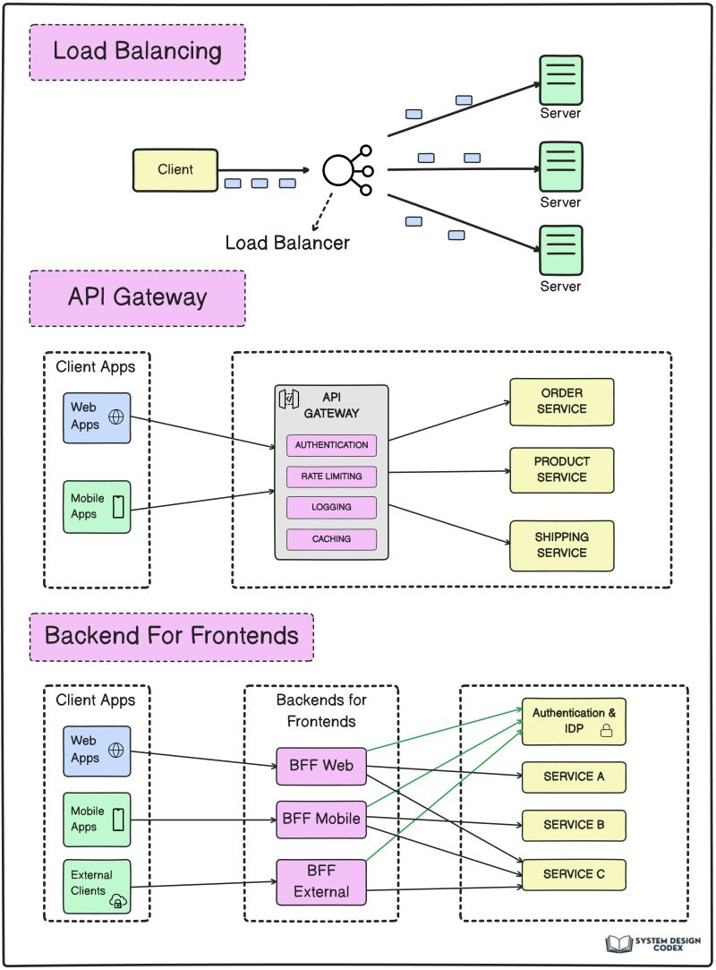

Load Balancer vs API Gateway vs Backend-For Frontend simplified.  
  
✅ Load Balancer  
  
When you check in to a hotel, you are usually greeted by a receptionist.  
  
The receptionist checks your documents, enters your info into their system, and guides you to your room.  
  
If there are too many guests, the hotel might keep multiple receptionists.  
  
Load balancers do a similar job for your application.  
  
It’s a tool that distributes incoming requests across multiple servers.  
  
Also, load balancers keep your system available. If one server goes down, it directs the request to another server.  
  
✅ API Gateway  
  
Imagine a scenario where a company is conducting interviews for various positions, such as Tech Architect, Engineering Manager, and Software Engineer.  
  
Each position has a dedicated interview panel.  
  
Now, you don’t want the candidates to check each room to find the correct panel.  
  
This is where a coordinator checks the candidate’s profile and directs them to the correct panel.  
  
For a system, API Gateway is that coordinator.  
  
API Gateways can also perform different functions like authentication, rate limiting, logging, and caching.  
  
✅ Backend for Frontend  
  
Let’s take our interview example further.  
  
For every position (Arch, Engineering Manager, Software Engineer), there are specific rounds of discussions.  
  
Some rounds are different based on the position but some may be common for all positions (such as the Director Round).  
  
How do you coordinate this for each position?  
  
Backends for Frontends is your BFF in this scenario. It’s a coordinator that takes care of the specific rounds for a particular type of interview.  
  
In system terms, BFF is the component that can take care of different device requirements.  
  
👉 So - have you used Load Balancers, API Gateways & BFFs?

Curious how websites load so fast worldwide? Here’s how a Content Delivery Network (CDN) makes it possible:  
  
1. Data Caching: CDNs store cached versions of your content in multiple geographic locations, reducing latency for users.  
  
2. Distributed Servers: Content is delivered from the server closest to the user, speeding up access times.  
  
3. Load Balancing: CDNs distribute traffic across multiple servers, avoiding overloading any one server and maintaining speed during high traffic.  
  
4. Security Enhancements: CDNs offer added protection against DDoS attacks by distributing traffic and shielding the origin server.  
  
5. Global Reach: CDNs allow your content to be accessible anywhere in the world, helping businesses with international audiences.  
  
6. Cost Efficiency: Reduces bandwidth costs by caching content at edge servers, minimizing the need to repeatedly fetch data from the origin.  
  
7. Fault Tolerance: If one server fails, the CDN reroutes traffic to the next closest server, ensuring continuous service.



Wondering how websites handle millions of users without crashing? Here’s how load balancers keep everything running smoothly:  
  
1. Traffic Distribution: Load balancers distribute incoming traffic across multiple servers to avoid overload.  
  
2. High Availability: They ensure that even if one server goes down, traffic is rerouted to another server without downtime.  
  
3. Efficient Resource Use: Load balancers optimize server usage, ensuring servers aren't underutilized or overburdened.  
  
4. Health Monitoring: Continuously checks server health to ensure requests are directed to healthy, functioning servers.  
  
5. Scalability: Allows businesses to add more servers as demand grows without disrupting service.  
  
6. Session Persistence: Ensures that users remain connected to the same server for the duration of their session, avoiding interruptions.  
  
7. Geo-balancing: Distributes traffic based on the geographic location of users, providing faster load times for global customers.  
  
With load balancers, websites maintain stability and speed even under heavy loads.





A load balancer is a tool that distributes incoming network or application traffic across multiple servers to ensure no single server is overwhelmed.   
  
This improves availability, reliability, and performance by efficiently handling requests and preventing server overload, ensuring smooth operation even during high traffic periods.  
  
Application Load Balancer (ALB):  
  
🔥 Operates at the Layer 7 (Application Layer) of the OSI model.  
🔥 Best suited for HTTP/HTTPS traffic and advanced routing, like path-based or host-based routing.  
🔥 Supports SSL termination, WebSocket, and stickiness.  
🔥 Ideal for handling dynamic web applications, microservices, and containerized environments.  
🔥 Provides content-based routing, meaning it can route requests based on content like URL paths or host headers.  
  
Network Load Balancer (NLB):  
  
☄️ Operates at the Layer 4 (Transport Layer) of the OSI model.  
☄️ Designed to handle TCP/UDP traffic and can manage millions of requests per second with low latency.  
☄️ Suitable for high-throughput, low-latency connections, such as database traffic or gaming applications.  
☄️ It’s simpler, focusing on forwarding network traffic to the correct destination.  
☄️ NLB is best when performance and scalability are critical and when managing large numbers of TCP connections.  
  
Both serve unique purposes, and the choice depends on the type of application and traffic you're dealing with!



𝗟𝗼𝗮𝗱 𝗕𝗮𝗹𝗮𝗻𝗰𝗲𝗿 𝟭𝟬𝟭  
Ever wondered how high-traffic websites and applications handle massive loads without crashing? The answer often lies in load balancers, the traffic cops of the digital world.   
  
𝗪𝗵𝗮𝘁 𝗗𝗼 𝗟𝗼𝗮𝗱 𝗕𝗮𝗹𝗮𝗻𝗰𝗲𝗿𝘀 𝗗𝗼?  
• 𝗗𝗶𝘀𝘁𝗿𝗶𝗯𝘂𝘁𝗲 𝗧𝗿𝗮𝗳𝗳𝗶𝗰: They intelligently spread incoming network or application traffic across multiple servers, preventing any single server from becoming overwhelmed.  
  
• 𝗘𝗻𝘀𝘂𝗿𝗲 𝗔𝘃𝗮𝗶𝗹𝗮𝗯𝗶𝗹𝗶𝘁𝘆 & 𝗥𝗲𝗹𝗶𝗮𝗯𝗶𝗹𝗶𝘁𝘆: By distributing the load, they ensure that if one server fails, the others can pick up the slack, minimizing downtime.  
  
• 𝗜𝗺𝗽𝗿𝗼𝘃𝗲 𝗣𝗲𝗿𝗳𝗼𝗿𝗺𝗮𝗻𝗰𝗲: Load balancing helps optimize resource utilization, leading to faster response times and a smoother user experience.  
  
• 𝗦𝗰𝗮𝗹𝗲 𝗔𝗽𝗽𝗹𝗶𝗰𝗮𝘁𝗶𝗼𝗻𝘀: As your application grows, load balancers make it easy to add more servers to handle the increased traffic.  
  
𝗧𝘆𝗽𝗲𝘀 𝗼𝗳 𝗟𝗼𝗮𝗱 𝗕𝗮𝗹𝗮𝗻𝗰𝗲𝗿𝘀  
• 𝗛𝗮𝗿𝗱𝘄𝗮𝗿𝗲: Dedicated physical devices, offering high performance but can be expensive.  
  
• 𝗦𝗼𝗳𝘁𝘄𝗮𝗿𝗲: More flexible and cost-effective, but might require additional server resources.  
  
• 𝗖𝗹𝗼𝘂𝗱-𝗯𝗮𝘀𝗲𝗱: Highly scalable and managed by your cloud provider, making them a great choice for cloud-native applications.  
  
• 𝗟𝗮𝘆𝗲𝗿 𝟰 (𝗧𝗿𝗮𝗻𝘀𝗽𝗼𝗿𝘁 𝗟𝗮𝘆𝗲𝗿): Make decisions based on IP addresses and ports.  
  
• 𝗟𝗮𝘆𝗲𝗿 𝟳 (𝗔𝗽𝗽𝗹𝗶𝗰𝗮𝘁𝗶𝗼𝗻 𝗟𝗮𝘆𝗲𝗿): Can understand application-specific data like HTTP headers and cookies, allowing for more sophisticated traffic routing.  
  
• 𝗚𝗹𝗼𝗯𝗮𝗹 𝗦𝗲𝗿𝘃𝗲𝗿 𝗟𝗼𝗮𝗱 𝗕𝗮𝗹𝗮𝗻𝗰𝗶𝗻𝗴 (𝗚𝗦𝗟𝗕): Distributes traffic across different regions, improving global performance and redundancy.

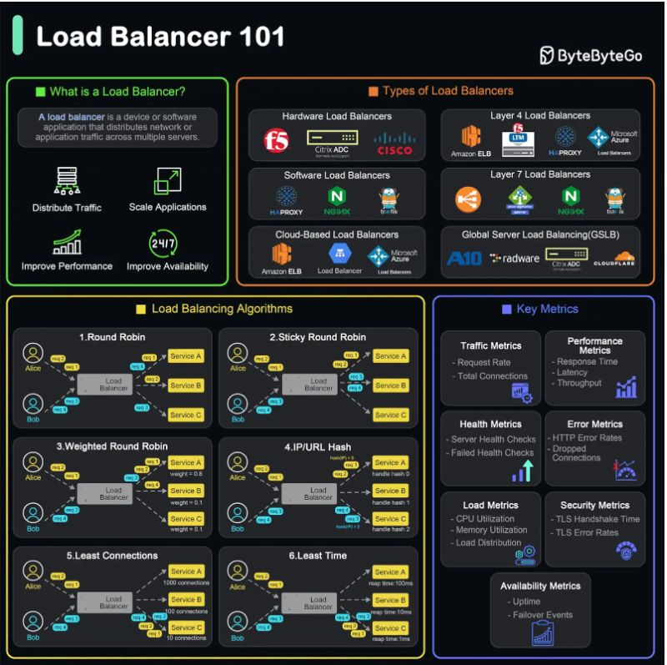

𝟖 𝐋𝐨𝐚𝐝 𝐁𝐚𝐥𝐚𝐧𝐜𝐢𝐧𝐠 𝐀𝐥𝐠𝐨𝐫𝐢𝐭𝐡𝐦𝐬 𝐘𝐨𝐮 𝐌𝐮𝐬𝐭 𝐊𝐧𝐨𝐰

  
Load balancers improve application performance by increasing response time and reducing network latency. They perform several critical tasks such distributing the load evenly between servers to improve application performance, redirecting client requests to a geographically closer server to reduce latency and much more.  
  
There are different types of load balancing algorithms.  
  
▪ Round Robin  
It assigns a request to the first server, then moves to the second, third, and so on, and after reaching the last server, it starts again at the first.  
  
▪ Least Connections  
The Least Connections algorithm directs incoming requests to the server with the lowest number of active connections.   
  
▪ Weighted Round Robin  
It assigns different weights to servers based on their capacities and distributes requests proportionally to these weights.  
  
▪ Weighted Least Connections  
The Weighted Least Connections algorithm combines the Least Connections and Weighted Round Robin algorithms. It directs incoming requests to the server with the lowest ratio of active connections to assigned weight.  
  
▪ IP Hash  
The IP Hash algorithm determines the server to which a request should be sent based on the source and/or destination IP address. This method maintains session persistence, ensuring that requests from a specific user are directed to the same server.  
  
▪ Least Response Time  
It directs incoming requests to the server with the lowest response time and the fewest active connections.  
  
▪ Random  
It directs incoming requests to a randomly selected server from the available pool.  
  
▪ Least Bandwidth  
It directs incoming requests to the server currently utilizing the least amount of bandwidth. This approach helps to ensure that servers are not overwhelmed by network traffic.



Advantage of 𝐀𝐏𝐈 𝐆𝐚𝐭𝐞𝐰𝐚𝐲  
  
- Single Point of Interaction: API Gateway centralizes communication between services.  
- Load Balancing: Distributes traffic evenly across services.  
- Aggregation of Results: Combines responses from multiple services.  
- Security and Authentication: Manages security centrally.  
- Performance Optimization: Reduces delays with caching.  
- Centralized Logging and Monitoring: Collects logs and metrics from all services.



𝟱 𝗡𝗲𝘁𝘄𝗼𝗿𝗸𝗶𝗻𝗴 𝗧𝗲𝗰𝗵𝗻𝗼𝗹𝗼𝗴𝗶𝗲𝘀 𝗘𝘅𝗽𝗹𝗮𝗶𝗻𝗲𝗱: API Gateway, Load Balancer, Reverse Proxy, Forward Proxy, and Service Mesh  
  
𝟭. 𝗔𝗣𝗜 𝗚𝗮𝘁𝗲𝘄𝗮𝘆: Imagine a traffic cop directing requests to the right microservices. That's the API Gateway! It handles API requests and ensures they reach the correct destination.  
  
𝟮. 𝗟𝗼𝗮𝗱 𝗕𝗮𝗹𝗮𝗻𝗰𝗲𝗿: Like a conductor distributing workload among musicians, the Load Balancer ensures tasks are shared equally among servers. This prevents overload and keeps everything running smoothly.  
  
𝟯. 𝗥𝗲𝘃𝗲𝗿𝘀𝗲 𝗣𝗿𝗼𝘅𝘆: Think of a bodyguard protecting servers. The Reverse Proxy handles requests on behalf of servers, keeping them safe from direct exposure. It also improves performance by caching and compressing data.  
  
𝟰. 𝗙𝗼𝗿𝘄𝗮𝗿𝗱 𝗣𝗿𝗼𝘅𝘆: Acting as a middleman, the Forward Proxy safeguards your privacy and security. It filters content, controls access, and protects your identity when browsing the internet.  
  
𝟱. 𝗦𝗲𝗿𝘃𝗶𝗰𝗲 𝗠𝗲𝘀𝗵: In a complex system of microservices, the Service Mesh is like the central nervous system. It manages communication, ensures reliability, and makes sure everything is working together seamlessly.